

**National university of Modern languages Islamabad**

**Faculty of computer science and engineering**

**Department of software engineering**

NAME: SYEDA KISA BATOOL

CLASS: BSSE 1ST SEMESTER EVENING

SUBJECT: IICT LAB

SUBMIT TO: SIR AQEEB ADIL

LAB REPORT WEEK 5

ROLL NO: SP 21128

Table of Contents

TOPICS WE COVERED IN WEEK 5 2

HOME TAB: 2

• New slides: 2

Purpose: 2

Steps with pictures: 2

Short key: 3

CTRL +M 3

• Layout 3

Purpose: 3

Steps with picture: 3

• Reset: 4

Purpose 4

Steps with picture 4

• Section 5

Purpose: 5

Steps with picture: 5

INSERT TAB 6

• Audio: 6

Purpose 6

Steps and pictures 6

• Video: 7

Purpose 7

Steps and pictures 7

• Slide number: 8

Purpose 8

Steps with picture 8

DESIGN TAB 10

• Slide orientation 10

Purpose 10

Steps with pictures 10

• Themes 11

Purpose 11

Steps with pictures 11

• Color 12

Purpose 12

Steps with pictures 12

• Font 13

Purpose 13

Steps with pictures 13

• Effect 14

Purpose 14

Steps with pictures 14

Transition tab: 15

• Preview 15

Purpose 15

Steps with pictures 15

• Transition to this slide 16

Purpose 16

Steps with pictures 16

• Sound 16

Purpose 16

Steps with pictures 16

• Duration 17

Purpose 17

Steps with pictures 17

POWER POINT

**INTRODUCTION:**

PowerPoint (PPT) is a powerful, easy-to-use presentation graphics software program which allows you to create professional-looking electronic slide shows. PPT is used to present information in an organized manner to an individual or group.

# TOPICS WE COVERED IN WEEK 5

# HOME TAB:

The Home Tab is used to perform many of the common tasks such as changing fonts, cutting and pasting text and images into presentations, changing paragraph formats, drawing objects, and editing text. some things are discussed as below

## New slides:

### Purpose:

New slide command is used to add a new presentation slide

### Steps with pictures:

* Click on the **Home tab,**
* 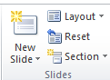Click on **New Slide**.
* In the **New Slide** dialog box, select the layout that you want for your **new slide**. Select **Add Slide**

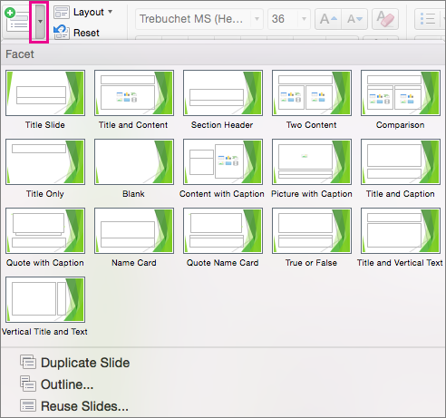

### Short key:

## CTRL +M

## Layout

### Purpose:

Layout is used to change the layout of selected slide

### Steps with picture:

* Select the slide that you want to change the layout for.
* ****Select **Home tab** then **Layout .**

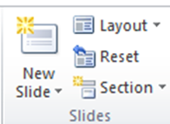

* 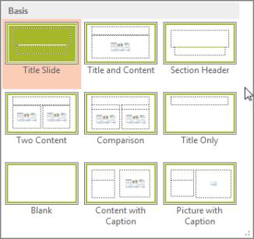Select the layout that you want. The layouts contain placeholders for text, videos, pictures, charts, shapes, clip art, a background, and more. The layouts also contain the formatting for those objects, like theme colors, fonts, and effects.

## Reset:

### Purpose

Reset is used to reset the size formatting and position of a slide

### Steps with picture

* Click on home tab



* Click on layout tab



* Click on the reset in slide family



## Section

### Purpose:

Section is used to organized your slides in sections

### Steps with picture:

* Right-click between slides and select Add Section. An Untitled Section is added in the thumbnail pane, and the Rename Section dialog box opens.
* Type a name in the Section name box.
* Select Rename.
* To collapse a section, click the triangle next to the section name.

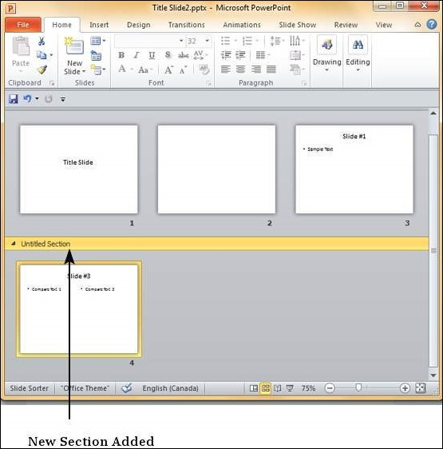

# INSERT TAB

## Audio:

### Purpose

Used to insert a audio clip in a slide

### Steps and pictures

* Click the Insert tab.



* Click the Audio icon.

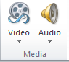

* In the drop-down menu that opens, select the Audio on My PC option.

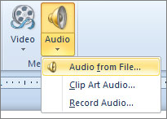

* In the Insert Audio window, find and select the sound file you want to insert into the PowerPoint slide, then click OK.
* After the sound file has been inserted, an icon that looks like a speaker with sound coming out of it appears. You can move the sound icon to another location on the slide.

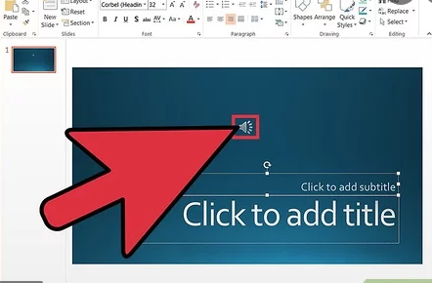

## Video:

### Purpose

Used to insert a video clip in a slide

### Steps and pictures

* Go to the slide in which you want to insert the video.
* Click on the **‘insert’ tab**
* Click on the arrow under **‘video’**.

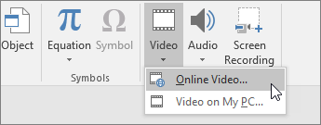

* Click on ‘video on My PC’.

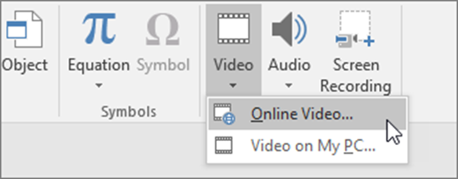

* In the **‘insert video’** box click on the video that you require to embed.
* Tap on **‘insert’.**

## Slide number:

### Purpose

Used to inset a slide number into the slides

### Steps with picture

* On the **Insert** tab, select **Slide Number**.

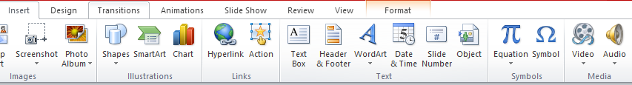

* On the **Slide** tab, check the **Slide number** box. If you don't want a **number** to appear on the title **slide**, also check the Don't show on title **slide** box.

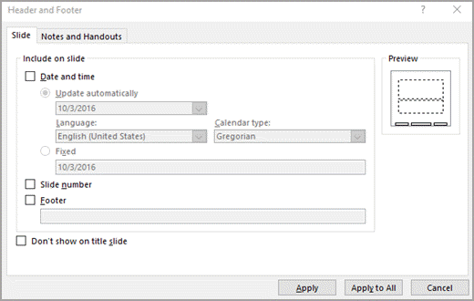

* Select Apply to All

. 

**National university of Modern languages Islamabad**

**Faculty of computer science and engineering**

**Department of software engineering**

NAME: SYEDA KISA BATOOL

CLASS: BSSE 1ST SEMESTER EVENING

SUBJECT: IICT LAB

SUBMIT TO: SIR AQEEB ADIL

LAB REPORT WEEK 6

ROLL NO: SP 21128

## DESIGN TAB

## Slide orientation

### Purpose

Used to switch the slide mode into the landscape and portrait

### Steps with pictures

* Click the Design tab.



* Select Slide Size.
* Select Custom Slide Size.
* Use the buttons in the Orientation section to select a vertical orientation or enter dimensions in the Width and Height fields.

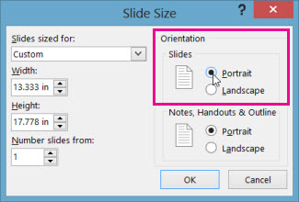

* Select OK to apply the changes.

## Themes

### Purpose

Used to select your favorite theme for the slide

### Steps with pictures

* Select the Design tab



* Then locate the Themes group. Each image represents a theme.



* Click the More drop-down arrow to see all available themes.

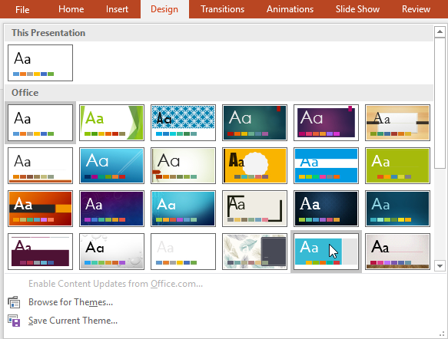

* Select the desired theme.
* The theme will be applied to the entire presentation. To apply a different theme, simply select it from the Design tab.

## Color

### Purpose

Used to change the color of a theme

### Steps with pictures

* Click on design tab



* Click Colors, and then click Customize Colors.

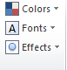

* Click the button next to the theme color you want to change
* Then pick a color under Theme Colors.

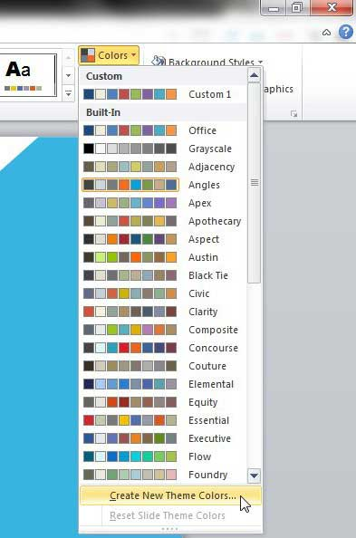

## Font

### Purpose

Used to change the font of the theme slide

### Steps with pictures

* Click on the design tab



* Click on font

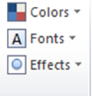

* Click on the font that you wanted to select

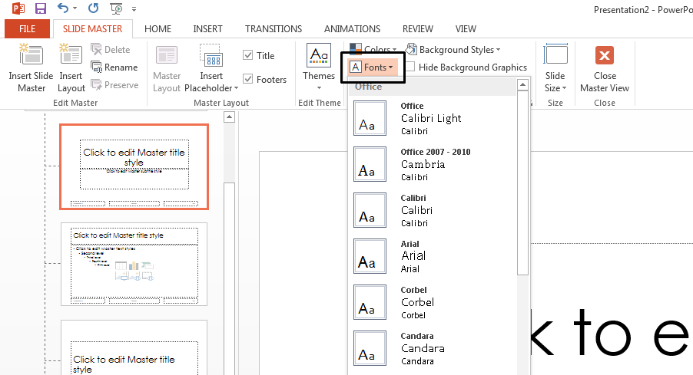

* Click okay

## Effect

### Purpose

Used to apply A effect on a theme

### Steps with pictures

* From the Design tab click the drop-down arrow in the Variants group and select Effects.



* Select the desired theme effects.

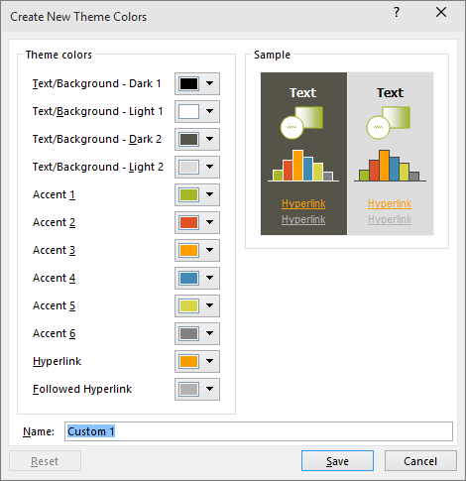

* Click on save to apply the changes

# Transition tab:

## Preview

### Purpose

Used to preview the transition of a slide

### Steps with pictures

* Select the transitions tab.
* Click on preview



* Or press f5 from the start

## Transition to this slide

### Purpose

Used to provide a transitions to your slides

### Steps with pictures

* Select the slide you want to add a transition to.
* Select the Transitions tab and choose a transition.



* Select Effect Options to choose the direction and nature of the transition.
* Select Preview to see what the transition looks like.

## Sound

### Purpose

Used to insert a sound to the slide

### Steps with pictures

* Select the slide to which you want to add the transition sound.
* Select the transition tab.



* In Transition to This Slide group click the drop-down arrow next to Transition Sound option.

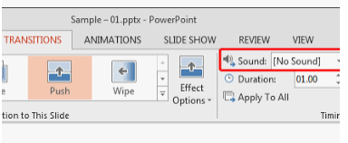

* A list of different transition sounds appears.
* Select the desired transition sound.
* Click Apply To All to apply the effect to all slide

## Duration

### Purpose

Used to add Duration to every slide

### Steps with pictures

* Select the slide that has the transition that you want to modify.
* On the Transitions tab,



* In the Timing group, in the Duration box, type the number of seconds that you want.

